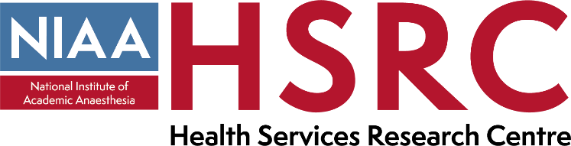
National Institute of Academic Anaesthesia (NIAA),
Health Services Research Centre (HSRC)
Post of HSRC Director

This post is a three-year fixed term appointment to direct, manage, develop and deliver the aims and objectives of the NIAA Health Services Research Centre (HSRC) in line with its strategic plan, ethos and policies.

The postholder will be required to chair the HSRC Executive Management Board meetings, contribute to the review and implementation of the HSRC’s strategic plan and lead on delivering the HSRC aims and objectives.

The successful candidate will also oversee the RCoA National Audit Projects and lead on the development of research and quality improvement projects.

The post is supported by 2 periods of professional activity (2 PAs) per week to enable the successful candidate to dedicate a minimum of 8 hours per week to the role.

For more information (including the job description and person specification) and to apply, please click here.

Further information about the HSRC is also available here: (www.niaa-hsrc.org.uk).

Those who are interested are strongly advised to discuss the role with Professor Ramani Moonesinghe, current Director of the NIAA-HSRC by email at ramani.moonesinghe@nhs.net and Ms Sharon Drake, Deputy CEO and Director of Clinical Quality and Research – sdrake@rcoa.ac.uk.

At RCoA diversity, equality and inclusion is an integral part of our culture so it is important to us that this is reflected in everything that we do. We welcome applications from all individuals irrespective of age, race, gender, sexual orientation, ethnicity, religion or belief, disability, marital status or parental responsibilities to ensure we actively embrace an inclusive and representative culture that encourages, supports and celebrates our differences.

Closing date for applications: Friday 26 March 2021

Interview date: Interviews will be held in April/May

